S A S T R A SCHOOL OF COMPUTING
DEEMED TO BE UNIVERSITY Third CIA Exam – May 2025
Course Code : INT314
Course Name : Artificial Inteligence and
Logical Reasoning
Duration : 90 minutes

Answer Any 4 Questions part A 4 X 10 = 40 Marks

1) Construct full joint distribution table for the following problem. Toothache may be caused due to cavity and/or the catch which the clinician uses.
The probability of having toothache
i) due to cavity and catch is 0.108
ii) due to cavity, but not catch is 0.012
iii) due to catch but not cavity is 0.016
iv) without catch and cavity is 0.064.
The probability of not having toothache
i) due to cavity and catch is 0.072
ii) due to cavity, but not catch is 0.008
iii) due to catch but not cavity is 0.114
iv) without catch and cavity is 0.576.
Calculate P(toothache), P(Cavity), P(toothache|cavity) and P(¬cavity|toothache). (10)

2)Discuss Resolution refutation steps of FOL with example. (10)
3)Magnuns and Hikaru are playing Chess game. They have decided to follow the strategy of min-max algorithm. As a friend you need to articulate the steps and the logic behind this algorithm enable them to choose the winning path. Give a part of sample tree. (10)
4) A) Find the unifier for the following FOL statements. (5)
i)Knows(Alpha,x) -Knows(Alpha,Beta),
ii)Knows(Alpha,x) – knows(y,Gamma),
iii)Knows(Alpha,x) – knows(y,Mother(y)),
iv)Knows(Alpha,x) -Knows(x,Gamma)
v)Knows(Alpha,x) – knows(y,z)
B) Define Illustrate and discuss CSP (5)
5) A) Illustrate the process of forward chaining using FOL (7)
B) Apply alpha beta pruning for the tree given below and provide alpha , beta values for each node and mark the pruned branch(s) if any (3)
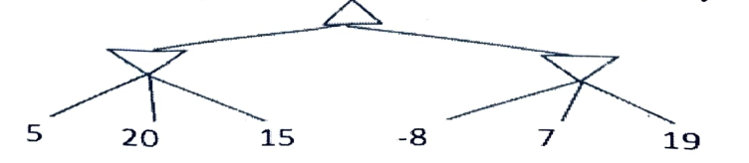

Answer ALL Questions PART B 1 X 10 = 10 Marks

6) Construct goal stack planning with block world example given below (10)

